EXPERIMENT 6
AIM:
GENERATION AND ANALYSIS OF FREQUENCY MODULATED (FM) AND OF PHASE MODULATED (PM) SIGNALS USING MATLAB

SOFTWARE REQUIRED:
MATLAB SIMULINK

PROGRAM:
Clc; clear; close all;
T=0:0.00001:0.02;
Fm=100; fc=1000;
M=cos(2*pi*fm*t);
C=cos(2*pi*fc*t);

FM=cos(2*pi*fc*t+5*sin(2*pi*fm*t));
PM=cos(2*pi*fc*t+pi*m);

Subplot(4,1,1);
Plot(t,m); title(‘Message Signal’); grid on;

Subplot(4,1,2);
Plot(t,c); title(‘Carrier Signal’); grid on;

Subplot(4,1,3);
Plot(t,FM); title(‘FM Signal’); grid on;

Subplot(4,1,4);
Plot(t,PM); title(‘PM Signal’); grid on;

OUTPUT:
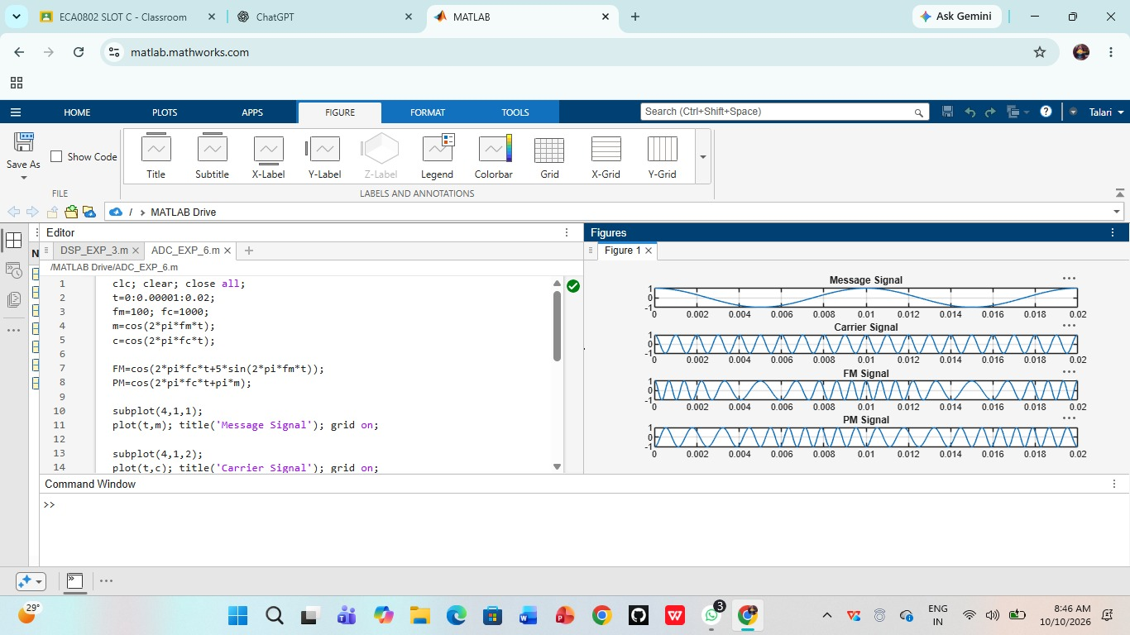

RESULT:
The Frequency Modulated (FM) and Phase Modulated (PM) signals were successfully generated using MATLAB by varying the instantaneous frequency and phase of the carrier signal according to the message signal.

